(Approx. 714 words)

Windows 11 "Accessibility" Features Introduction
by Tom Burt, Vice President
Sun City Summerlin Computer Club
https://www.scscc.club
tomburt89134 ** cox.net

This month, we'll look into a collection of Windows 11 settings called the "Accessibility" features. These features are aimed at helping users who have various challenges, such as impaired vision or hearing or physical handicaps that make using a mouse and keyboard difficult. Much of this material also applies to Windows 10's "Ease of Access" settings.
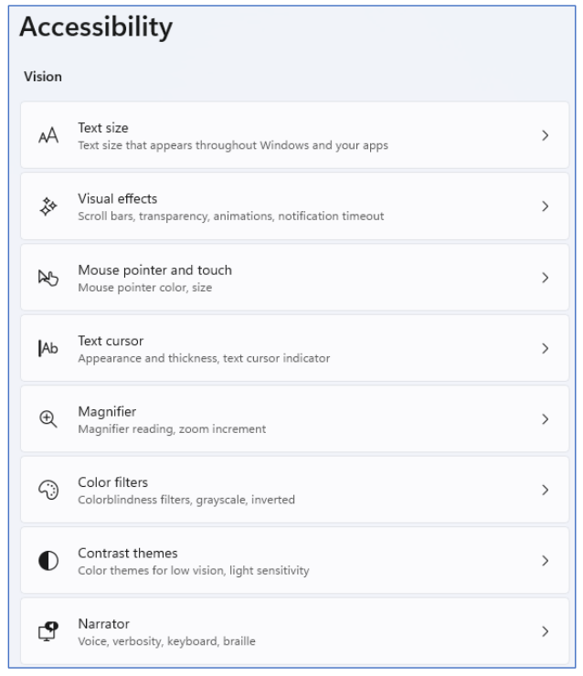
Accessibility Settings Screen – Vision

Many of the Accessibility settings are also helpful for non-challenged users, so it's worth learning more about these.

To reach the Accessibility settings, click the Windows Start icon in the Taskbar and then the Settings (Gear) icon. Then, in the main Settings window, click Accessibility.

The Accessibility settings are divided into three main categories: Vision, Hearing, and Interaction. The screenshot above shows the Vision settings.

The "Text Size" setting can be useful when working on a high-resolution screen with small font sizes (8 or 10 points). You can use the slider to scale up the fonts displayed on the screen to make them more readable. For example, I've scaled up text sizes by 10% in the screenshot below. The range on the slider is 100% (no scaling) to 225%.
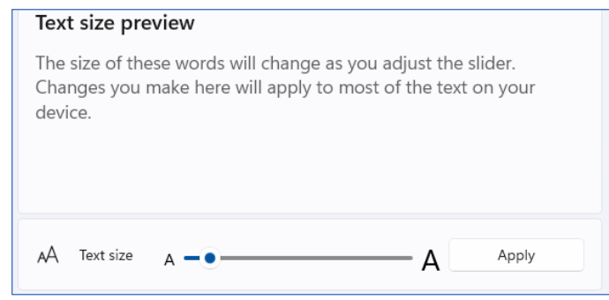
Text size setting

The "Visual Effects" setting allows you to control (via an On/Off slider) whether scrollbars are always shown or fade into view as you hover the mouse over a window. There are also sliders for Transparency and Animation effects and a dropdown for how long notifications are on the screen.

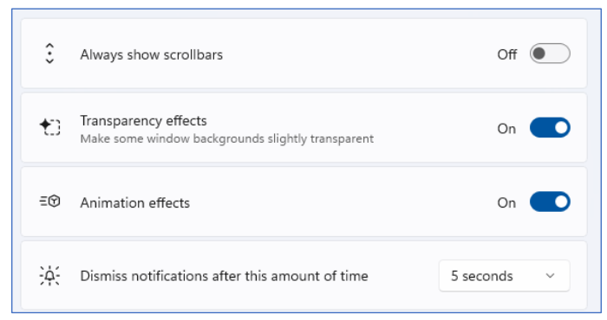
Visual effects setting
The "Mouse pointer" setting allows you to select the mouse pointer's style, color, and size. The size slider goes in steps of 1, representing a scale factor. For example, I've selected the outline pointer with a color of gold and a scale factor of two. This makes it easier to see and follow.
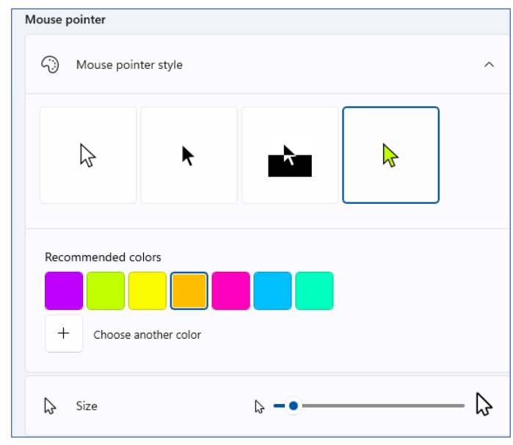
Mouse pointer setting

The last Vision setting we'll look at is the Magnifier. See the screenshot below. The Magnifier is turned on by pressing the Windows and + keys together. This will magnify (scale up) the screen by the Zoom level setting (default is 200%). You can turn off the Magnifier by pressing the Windows and Esc keys together.

You can press the Windows key and the + key together to increase the scale by the Zoom increment and press the Windows key and the – key together to decrease the scale by the Zoom increment. You can also press the Ctrl and Alt keys together and use the scroll wheel on your mouse to scale the Magnifier up or down.

You can pan around the magnified screen by moving your mouse pointer to the edges of the magnified screen. I'll leave it to my readers to explore the other Vision settings on their own.

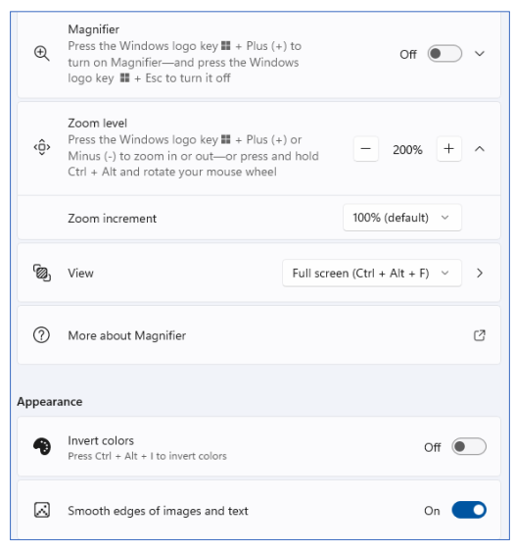
Magnifier setting

Under the Accessibility > Hearing settings is one for Captions styles settings. These allow you to configure how closed captions appear on your screen. You can select from several default layouts or create a custom layout of your own. Settings > Accessibility > Captions. Click the button for Caption style and change it from default to another option, such as White on black, Small caps, Large text, or Yellow on blue.

Under Accessibility > Interaction (see the following screenshot) are various settings for Speech recognition and dictation, special keyboard behavior, using the keypad to move the mouse cursor, and using an eye tracker device to allow you to type using eye movements. For example, see the screenshot following.

Voice typing (dictation) is very easy to use. Place the mouse cursor into any text box on the screen (e.g., a Notepad or MS Word window) and press the Windows and H keys together. A small window will appear with a microphone icon in it. Click the icon to turn the microphone on or off. You can dictate when the microphone is on, and Windows will convert your spoken words to text in the on-screen textbox.

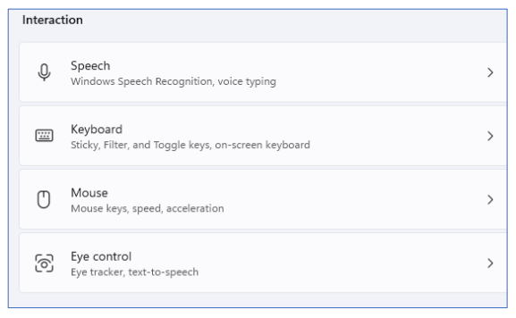
Interaction settings

The following is an example of dictation in a Notepad window. Once you have dictated into Notepad, WordPad, MS Word, or any other editor, you can edit, copy and paste the resulting text as if it had been typed in on the keyboard.

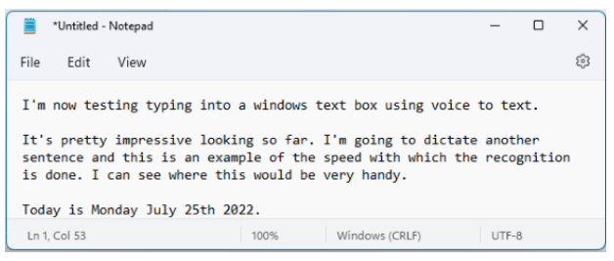
Voice Typing Example

